Square One: the game idea
Oct 24, 2026 · @gfx

The game
Square One is a retro first-person dungeon game, in the style of 90s classics like Doom, where the dungeon is built by AI from the skill you want to learn. Every room is one step of your roadmap, every monster is a common mistake, and the only way through the next door is to prove you learned the last room.
- You type a skill. The AI builds a fort for it: 4 floors (the stages) with 5 rooms each (the steps), 20 rooms in all.
- You walk through it in first person. Each room has a glowing terminal with one small task, a monster carrying a question, and a locked door.
- Room 1 of every fort is called Square One. Tagline: Everyone starts at square one. Nobody stays there.
- Our own world, not a copy. We borrow the feel of the classics (first person, keys, doors, a map, monsters, a stats screen). Every picture, name and sound is ours.
Why a real game wins this brief
The brief asks | In Square One
Pick a goal, get an AI roadmap | The fort is the roadmap. The map screen shows all 20 rooms and your dot.
Clear steps and next actions | A line at the top always says what to do next: "Get the green key: finish Store things in variables". The game walks you to the next door.
Visible progress | The map fills in as you go, the floor percentage sits in the corner, and every floor ends with a stats screen.
From "where do I start?" to a confident first step in 60 seconds | Room 1 is a 2-minute task and the easiest monster in the game.
Meet learners wherever they are | A 10-second warm-up starts you on floor 2 if you know the basics. Secret walls let you skip rooms you already know.
No one gets lost | If a monster beats you, a portal takes you to the room that teaches that exact thing, then brings you back.
Extra points: fun | Health, combos, keys, secrets, bosses, ranks. A real game, not a checklist with points stuck on.
Extra points: simple | Nothing to learn. On a phone the game moves for you; you only tap one of 4 answers.
Every other team will show a list of steps with an XP bar. A first-person game, rebuilt by AI for any skill, running in a phone browser, is not something one prompt produces.

How you play
One loop, repeated 20 times: learn the step, prove it to a monster, take the keycard, walk through the door.
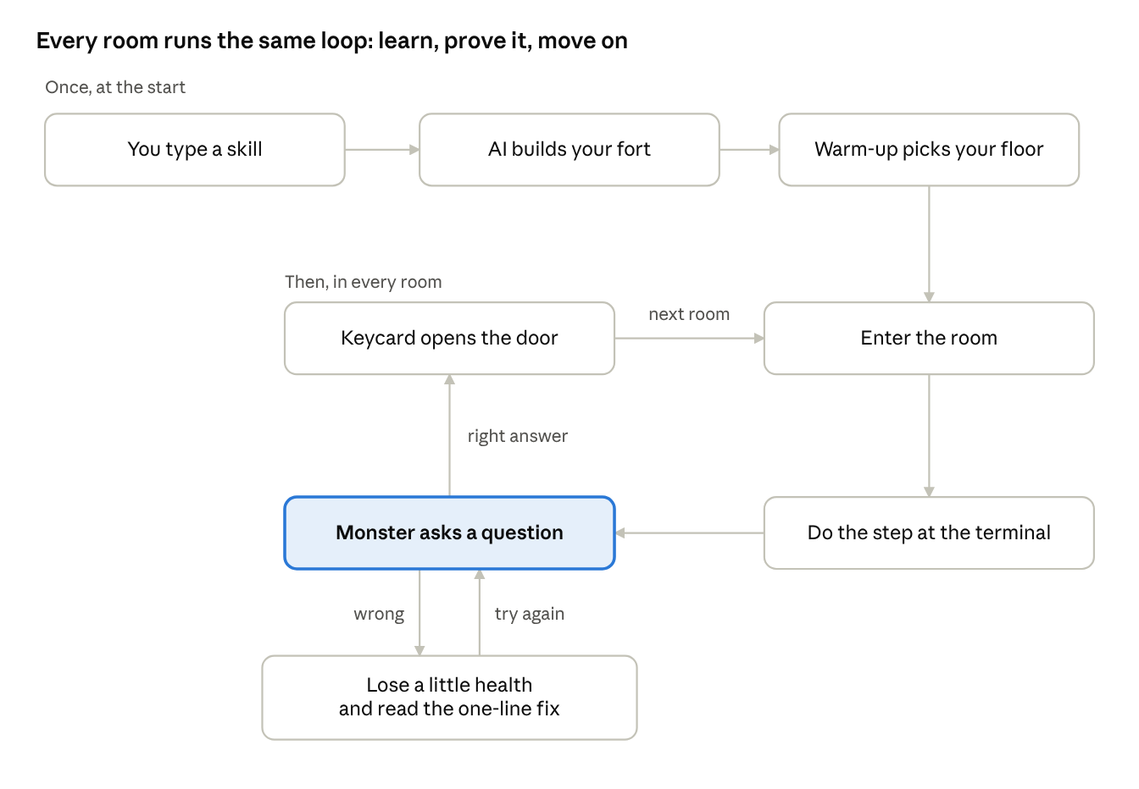
core loop · 3 setup steps, 4 steps per room
Two twists sit on top of the loop. Every 5th room ends the floor with a boss and a stats screen. In rooms 14 and 18, an elite monster asks about an earlier room; lose to it and a portal sends you to the room that teaches that exact thing, then back.

Game pieces
Every classic game piece has one learning job, so playing the game and following the roadmap are the same thing.
Game piece | What it does in the game | What it means for learning
Rooms | 20 rooms, 5 per floor | 20 small steps, 5 per stage
Terminal | A glowing screen in each room. Walk up to it and it opens. | The step: why it matters, 3 to 5 things to do now, one real video, "you're done when"
Monster | Steps out after you close the terminal, carrying a question | The most common mistake on this step
4 weapons | Keys 1 to 4 on a laptop, 4 big buttons on a phone. Fire the right one to pop the monster. | The 4 answer options
Keycard | Dropped by the monster | Proof you finished the step
Door | Opens with the keycard | The next step unlocks
Map | Press M or tap the map icon | The whole roadmap: rooms done, rooms left, "you are here"
Secret wall | A cracked wall in rooms 3 and 12. Answer 3 quick questions to break it. | Skip 5 rooms you already know
Elite monster | Waits in rooms 14 and 18, asks about an earlier room | Catches the classic mistakes that come back later
Portal | Opens if an elite monster beats you | Takes you to the room that teaches that mistake, then straight back
Floor boss | End of each floor, 3 hits to beat | A quick mixed review of the floor
Final boss | Room 20 | Checks the small real project
Health | Drops on a wrong answer. At zero you restart the room, nothing is lost. | Gentle stakes, never punishment
Armour | +1 for each day in a row you play | The daily streak
- Monster names are written by the AI for each skill: the Off-by-One Imp for Python, the Wrong-Tense Troll for Spoken English, the Broken-Formula Ghoul for Excel. They burst into pixel dust. Nothing gory.
- Moving around: on a phone, the game glides you from the terminal to the monster to the door; you only tap. On a laptop you can also walk freely with the arrow keys to hunt for secrets.

The first 60 seconds
A new player clears their first room within a minute of typing their goal.
- Title screen. One question: "What do you want to learn?" Type it, or tap one of 6 ready-made skills. Pick English, Hindi or Hinglish.
- Warm-up while the fort is built. The AI needs about 10 seconds. You spend them shooting 3 practice dummies, each carrying an easy-to-harder question. Hit all 3 and the lift takes you straight to floor 2. Miss and you start at Square One. This is how the game meets you where you are.
- Spawn in Square One. The terminal glows. The top line says: "Walk to the terminal."
- The terminal. A task you can finish in under 2 minutes on a phone (for Python: open a free online editor and print your name).
- The first monster. It steps out with one easy question. Tap the right weapon, it pops, drops the keycard, the door slides open. "Room 1 cleared."
Demo script for the judges
Time | What you do | What you say
0:00 to 0:08 | Title screen on the projector. | "Learning a new skill feels like a maze with no map. So we made it a game with a map."
0:08 to 0:20 | Type "Python". Shoot the warm-up dummies while the fort builds. Spawn in Square One. | "The AI just built a fort for Python. Every room is one step."
0:20 to 0:35 | Open the terminal, show the task and the real video. Close it. The Off-by-One Imp appears. Fire the right weapon. Keycard, door opens. | "You prove it to get through. That's the whole game."
0:35 to 0:48 | Press M. The map shows 20 rooms, your dot, the secret walls. | "This is your roadmap. You always know where you are and what's next."
0:48 to 1:00 | Load the saved game at room 14. Lose to the elite monster on purpose. The portal drops you in room 7, then back. | "Get a classic mistake wrong and you go to the exact room that fixes it. Nobody gets lost. Everyone starts at square one. Nobody stays there."
Keep a saved game at room 14 and a fort already built in a second tab, in case the venue wifi is slow.

Rewards
The brief names four things for the fun extra points: progress, streaks, feedback and reward. Each one has a clear home in the game.
The brief's word | In Square One
Progress | The map fills in room by room. Floor percentage in the corner. A stats screen after every floor.
Streaks | Armour: +1 for each day in a row you play, shown on the bottom bar. Combos: right answers in a row multiply your score, up to 5 times.
Feedback | Instant: the monster pops on a right answer. On a wrong one it hits you, the screen flashes, and a one-line fix appears under it.
Reward | Score, keycards, secrets, badges, and a rank for every floor.
Score. 100 points for each monster, times your combo. +50 if right on the first try. +500 for each secret found. +1,000 for each boss.
End-of-floor stats screen, shown with a drum roll as each line counts up:
- Monsters beaten on the first try, as a percentage
- Secrets found on this floor
- Your time against the par time (the AI sets par from how long each step should take)
- Rank: S, A, B or C
Badges: First Room, Untouchable (a whole floor with no wrong answers), Secret Hunter, Portal Survivor, 3-Day Streak, Fort Conquered.

Look and sound
A night fort lit by marigold torches, drawn in chunky retro pixels: it looks like a real 90s game, and like nothing else in the room.
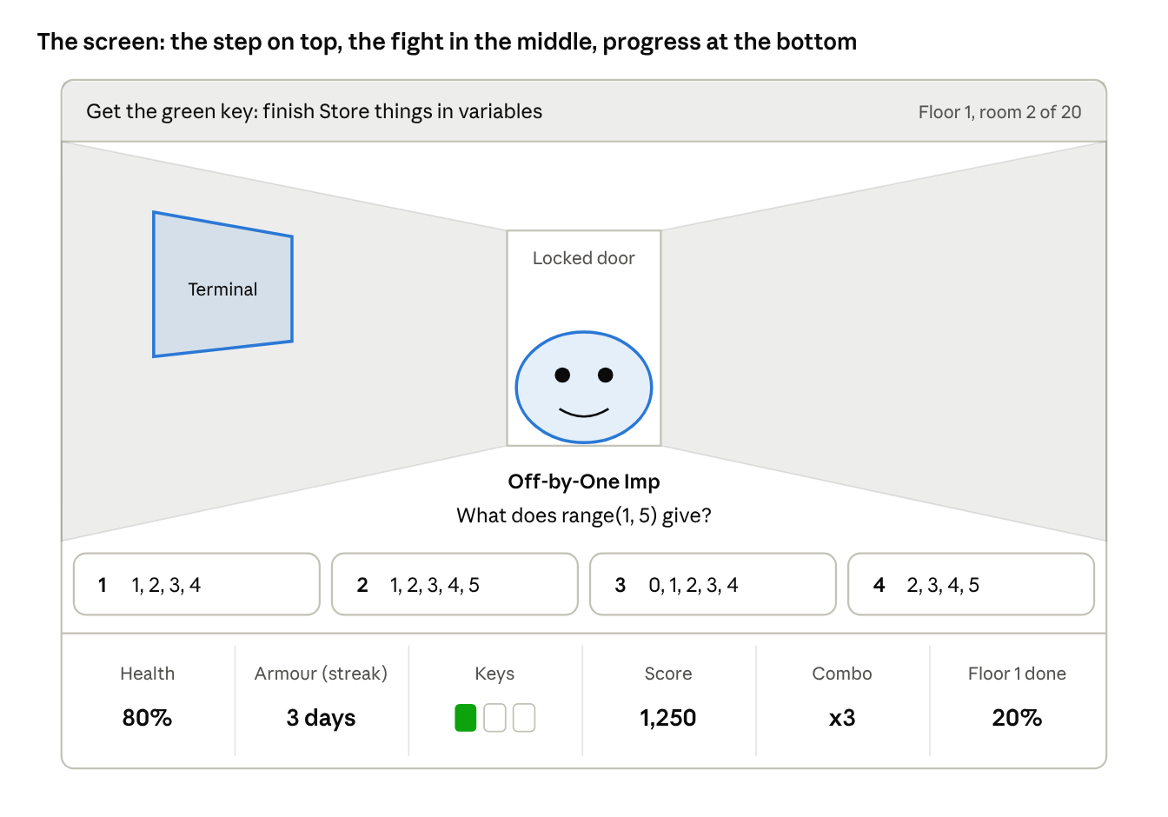
game screen · objective, view, 4 answer weapons, status bar
- The world: sandstone walls, indigo tiles, marigold torchlight, a new floor colour for each of the 4 floors. Every room is the same proven shape, so the code never builds a broken level.
- Pixels: the picture is drawn at 320 by 200 pixels and scaled up. That gives the retro look and keeps it fast on a cheap phone.
- Text you read (terminal, questions) uses a clean, large font. Text that's game chrome (score, health, titles) uses a pixel font such as Press Start 2P, free on Google Fonts. Hindi text falls back to a font that supports Hindi.
- Sound: chiptune music, a satisfying pop on a right answer, a low thud on a wrong one, a door whoosh, and a drum roll on the stats screen. A mute button sits in the corner.
- On a phone: the 4 answer weapons become 4 big buttons across the bottom, above the status bar.

What the AI makes and what the code makes
The AI writes the words; the code builds the world. That way the AI can never produce a broken level, and every fort is always playable.
Part | Made by | When
Fort name, 4 floor names, 20 room titles with a one-line "why" | AI | When you type your goal, about 10 seconds
3 warm-up questions | AI | At the same moment, in a separate quick request
Each room's terminal: steps, "done when", video search words | AI | In the background, one room ahead of you
Each monster's name, question, 4 answers and one-line fix | AI | Same time as its room
Secret wall, elite monster and boss questions | AI | With the fort
Par time for each floor | AI | With the fort
Video choice | Code, using real YouTube numbers | When a terminal opens. The AI only writes search words; the app compares up to 8 real videos by views, likes and length.
Map layout, walls, doors, lights | Code | Always the same proven layout, so nothing can break
Monster looks | Code | 8 hand-made pixel monsters; the AI's name goes on top
3D view, movement, sounds, score, saving | Code | Always
- How the 3D works, in one line: the same drawing trick the 1992 game Wolfenstein 3D used. The picture is drawn small and scaled up, so it runs smoothly on a cheap Android phone.
- No login. Progress saves in the browser.
- A built-in sample fort (Python) works with no internet and no AI. It's the backup for the demo.

What to build in the time left
Build the "must" list first and get it online before touching anything else. Anything not working by hour 8 gets cut.
Must (the demo needs every one of these)
- ☐ Title screen: one input box plus 6 ready-made skills
- ☐ AI fort and room content, plus the offline sample fort
- ☐ Warm-up dummies while the fort is built
- ☐ First-person view with walls, doors, terminals and monsters (glides on a phone, arrow keys on a laptop)
- ☐ Terminal card with the steps and one real video
- ☐ Monster fights with 4 answer weapons, health and keycards
- ☐ Elite monster in room 14 and the portal back to room 7
- ☐ Map screen
- ☐ Objective line at the top, status bar at the bottom
- ☐ End-of-floor stats screen
- ☐ A saved game at room 14 for the demo
Nice (adds points if there's time)
- ☐ Secret walls in rooms 3 and 12
- ☐ Floor bosses and the final boss
- ☐ Sounds and chiptune music
- ☐ Hindi and Hinglish
- ☐ Armour streak and badges
Cut unless everything else is done
- ☐ Free walking on a phone
- ☐ WhatsApp reminders
- ☐ Racing a friend through the same fort

Merging with your teammate's idea
The heart of the game stays fixed; everything around it is an open slot your teammate's idea can fill.
Fixed (this is what makes it work for the brief): the fort is the roadmap, one room is one step, you prove what you learned to open the door, monsters are common mistakes, and the portal sends you back to fix them.
Open slot | Today's default | Your teammate's idea could bring
World and story | A night fort lit by marigold torches | Any other world or story
Characters | 8 pixel monsters and a faceless hero | Their own hero and monsters
Extra rewards | Score, combos, armour, ranks, badges | Their reward system
Playing with others | None | Racing friends, a class leaderboard
Outside the game | None | WhatsApp reminders, daily challenges
Send me your teammate's idea and I'll merge the two into one design.

